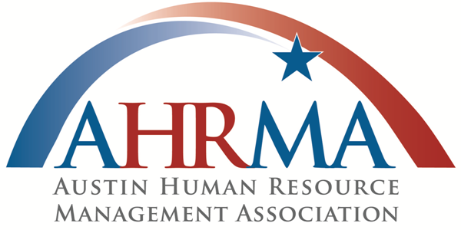
Beyond HR:
A Changing World
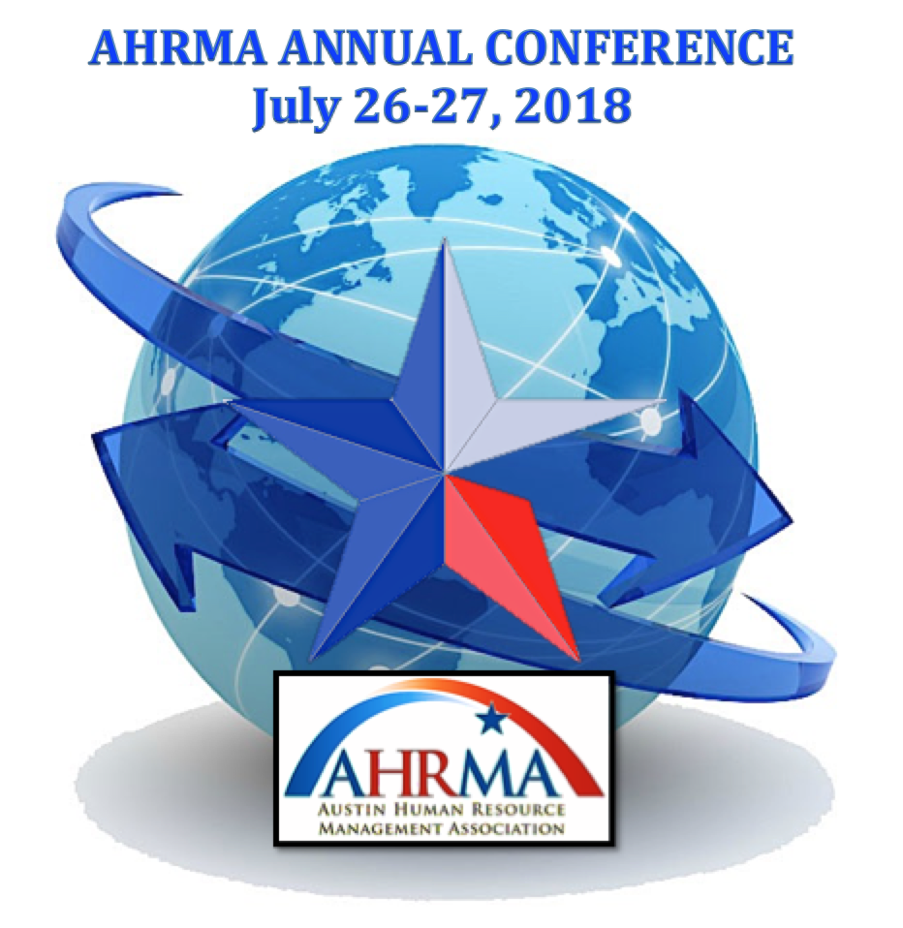

SPONSOR & EXHIBITOR PROSPECTUS

ABOUT THE CONFERENCE

The Austin Human Resource Management Association, (AHRMA) is the local chapter of the Society of Human Resource Management; (SHRM) invites you to be part of the 2018 Annual Conference. This Conference is the premier educational and networking event for HR professionals in the Austin and Central Texas area. The annual AHRMA Conference hosts more than 300 attendees, speakers, sponsors, and exhibitors each year.
The 2018 AHRMA Conference will be a dynamic environment dedicated to making new business connections and showcasing the newest innovations in HR solutions and services. The 2018 AHRMA Conference will also include some of the most popular Conference activities, including lunch, breaks, a silent auction, door prizes, and more!

SPONSORS & EXHIBITS
Participating companies represent a wide variety of HR solution and service providers, including, but not limited to:
COMPENSATION & BENEFITS | HRM PROGRAMS & SERVICES
Child Care, Elder Care, Dependent Care | Business continuity & Recovery
Financial | Legal Services
Food Service | Management Consulting
Health Care Cost Containment | Organizational Planning & Development
Insurance: Health, Life, Dental, Vision, etc. | Outsourcing
Pensions/Retirement Benefits | Personnel Research, Survey Results
Retirement/Pre-Retirement Planning | Professional Books, Magazines, Manuals
Surveys | Recognition Awards, Incentives
Third Party Administrators | Relocation Services
Voluntary Benefits | Travel, Airline, Hotel, etc.
Wage & Salary Administration
Workers’ Compensation
EMPLOYEE RELATIONS, LABOR RELATIONS | PROFESSIONAL DEVELOPMENT
Affirmative Action/EEO | Assessment, Assessment Tools
Arbitration, Mediation, Dispute Resolution | Business Education, Accounting, Marketing, etc.
Communications, Employee Newsletters | Certification, Certificate Program
Diversity Services | Coaching, Mentoring
Employee Engagement | Distance Learning
Labor Relations | HR Professional Development
Performance Management, Appraisals | Leadership
GLOBAL HR | Management/Executive Development  Seminars, Educational Programs
Cultural Awareness, Cultural Competence | Training Materials & Methods
Eligibility Verification (I-9), Immigration and Visas | Universities, Colleges, etc.
Global Assignment Management
Global Employment Law | TALENT MANAGEMENT
Global Relocation | Applicant Tracking
Outsourcing | Background Investigations
HEALTH, WELLNESS & SAFETY | Contingent Staffing, Employment Agencies  Executive Search
Counseling, Employee Assistance Programs (EAPs) | Outplacement
Drug/Alcohol Treatment & Testing | Pre-Employment & Employee T4esting
Emergency Response | Recruitment
Health Promotion, Recreation, Wellness Benefits | Recruitment Advertising
On-site Medical Care
Personal Fitness & Health Programs | TECHNOLOGY
Risk Management | External (Software as a Service – SaaS) Hosted
Safety | Applications
Security | HR Information Systems (HRIS
WHAT’S NEW IN 2018
AHRMA strives to deliver a fresh, interesting, and rewarding experience each year. Here are some of the exciting new opportunities exhibitors and sponsors can look forward to in 2018.
- Premium Sponsors have access to all educational sessions so you can learn along with your new clients, customers and colleagues.
- Reshaped floor plan to enhance traffic flow, visibility and to allow for more interaction with the attendees.
- Booth Setup reconfigured in order to increase exhibitor and sponsor interaction to make new connections.
- Mobile Charging Station lounge
- Advance Social Media/Pre-Conference Publicity

EVERY EXHIBITOR WILL RECEIVE THE FOLLOWING BASIC PACKAGE:
- NEW – Pre Conference Social Media Publicity
- 10’ x 10’ booth
- One 6-ft. skirted table, two chairs, one 7” x 44” company sign and one wastebasket
- 8 ft. high draped back wall, 3-ft high draped side walls
- Two exhibit hall registrations per Sponsor. Additional exhibit hall registrations available at $75 each.(No substitutions of Exhibit Hall Badges for Registration Badges.)
- Networking opportunities including lunch, networking night and beverage breaks
- Complimentary admission to Keynote and the closing session
- Complimentary lunch & beverage breaks for registered booth staff on Friday
- Conference bag with conference materials (one per Exhibit Hall Badge.)

CONFERENCE LOCATION & HOTEL ACCOMMODATIONS. Both the 2018 AHRMA Conference and Hotel accommodations will be at the same location.

Hyatt Regency Austin
208 Barton Springs
Austin, TX 78744

2018 CONFERENCE SCHEDULE* (TOTAL OF 6.0 CE)
THURSDAY – JULY 26TH
- 3:00 PM - 4:00 PM Hyatt Exhibit Hall Set Up
- 4:00 PM - 6:00 PM Exhibitor Registration and Move In
All booths must be set up by 6:00 PM on Thursday, 7.26.2018
- 6:00 PM – 8:00 PM AHRMA NETWORKING NIGHT

FRIDAY – JULY 27TH (6 CE)
- 7:00 AM – 8:00 AM Attendee and Speaker Registration Opens |
Welcoming Remarks | Platinum Sponsor |
- 8:00 AM – 9:00 AM Keynote (1 hour)
- 9:15 AM – 10:15 AM Sessions (1 hour) 4 concurrent sessions
- 10:15 AM – 11:00 AM Break with Exhibitors (45 min)
- 11:00 AM – 12:00 PM Sessions (1 hour) 4 concurrent sessions
- 12:00 PM – 12:30 PM Lunch Buffet
- 12:30 PM – 1:30 PM Keynote (Executive Track included)
- 1:45 PM – 2:45 PM Sessions (1 hour) 4 concurrent sessions
- 2:45 PM – 3:30 PM Break with Exhibitors (45 min)
- 3:45 PM – 4:45 PM Sessions (1 hour) 4 concurrent sessions
- 5:00 PM – 5:30 PM Closing remarks| Drawings | Grand Prize Drawing
Registered sponsors & exhibitors invited to join.

* Conference schedule is subject to change

SPONSOR/EXHIBITOR PACKAGES
PLATINUM LEVEL - $4,500 - 3 Remaining Early Bird $3,800
BREAKFAST KEYNOTE SPONSOR – EXCLUSIVE
Your company’s representative makes remarks from the podium to introduce the Keynote Speaker on Friday. Special recognition from VP Conference during breakfast presentation.
LUNCH KEYNOTE SPONSOR – EXCLUSIVE (Sold Out)
Your company’s representative makes remarks from the podium to introduce the Keynote Speaker on Friday. Special recognition from VP Conference during lunch presentation.
TOTE BAG SPONSOR – EXCLUSIVE (Sold Out)
Your company’s logo co-branded with AHRMA and SHRM logos on the Conference tote bags. Great advertising for your company as bags are handed out to all attendees. Special recognition from VP Conference during lunch presentation.
NETWORKING NIGHT – EXCLUSIVE
Your company will be prominently advertised in the Networking Night area. Special recognition from VP Conference during opening remarks on Friday morning.
HOSPITALITY & WELLNESS LOUNGE – EXCLUSIVE
Your company will be prominently advertised in the Hospitality & Wellness Lounge. Special recognition from VP Conference during opening remarks on Friday morning.
INCLUDES:
- 10 x 10 booth in prime location
- Recognition in the AHRMA Newsletter before Conference
- Pre and post attendees list
- 1/2 page ad in Conference program
- Social media mentions on all digital marketing channels
- 2 full Conference registrations, including refreshments and lunch

DIAMOND LEVEL SPONSOR - $3,000 – 4 Remaining Early Bird $2,500
- AUDIO & WIRELESS SPONSOR – EXCLUSIVE
Your company will be prominently advertised in the registration area. Special recognition from VP Conference during opening remarks Friday morning.
- WIFI SPONSOR – EXCLUSIVE (Sold Out)
Your company’s name will be used as the wifi password. Special recognition from VP Conference during opening remarks Friday morning. *additional fee associated
- MOBILE CHARGING STATION SPONSOR – EXCLUSIVE
Your company will be prominently advertised in the charging station lounge. Special recognition from VP Conference during opening remarks Friday morning.
- PROGRAM BROCHURE SPONSOR – EXCLUSIVE
Your company’s logo co-branded with AHRMA and SHRM logos on the cover of the digital program brochures. Great advertising for your company as these digital programs are sent out to the all registered attendees prior to the conference. Special recognition from VP Conference during lunch presentation
- LUNCH SPONSOR – EXCLUSIVE
Your company will be prominently advertised in the food buffet area with flyers at each lunch table. Special recognition from VP Conference during opening remarks Friday morning.
INCLUDES:
- 10 x 10 booth in prime location
- Pre and post attendees list
- Special recognition from VP Conference during lunch presentation
- 1/2 page ad in Conference program
- Social media mentions on all digital marketing channels
- 2 full Conference registrations, including refreshments and lunch

GOLD LEVEL SPONSOR - $2,350 – 2 Remaining Early Bird $1,950
- GRAND PRIZE SPONSOR GUARANTEED $2000 DOOR PRIZE – EXCLUSIVE (Sold Out)
Your company’s promotional item or advertisement included in all attendee tote bags.
- BADGE SPONSOR – EXCLUSIVE
Your company’s logo printed in high quality on all attendee badges
- LANYARD SPONSOR – EXCLUSIVE (Sold Out)
Your company’s logo printed in high quality on all attendee lanyards.
- PARKING GARAGE PASS SPONSOR – EXCLUSIVE
Your company’s logo printed in high quality on a parking THANK YOU note inserted in all attendee tote bags. Special recognition from VP Conference during opening remarks on Friday morning.
INCLUDES:
- 10 x 10 booth in select location
- Pre and post attendees list
- Recognition by VP Conference
- 1/2 ad in Conference program
- Social media mentions on all digital marketing channels
- 2 full Conference registrations, including refreshments and lunch

SILVER LEVEL SPONSOR - $1,850 – 0 Remaining Early Bird $1,500
- BREAKFAST SPONSOR (Sold Out)
- Company advertising prominently displayed throughout the breakfast area
- MORNING REFRESHMENT BREAK SPONSOR (Sold Out)
Company advertising prominently displayed throughout all refreshment areas
- AFTERNOON REFRESHMENT BREAK SPONSOR (Sold Out)
Company advertising prominently displayed throughout all refreshment areas
INCLUDES:
- 10 x 10 booth in select location
- Pre and post conference attendees list
- Recognition by VP Conference
- 1/2 page ad in Conference program
- Social media mentions on all digital marketing channels
- 2 full Conference registrations, including refreshments and lunch
BRONZE SPONSOR - $1,300 – 0 Remaining Early Bird $1,000
- SESSION ROOM SPONSORS – Company name prominently displayed in the room as a stand-alone display. Two sponsors per room.
INCLUDES:
- 10 x 10 booth in select location (Animal Sponsor – 8x8 booth in Wellness Lounge)
- Recognition in the AHRMA newsletter
- Pre and post attendee list
- 1/4 page ad in Conference program
- Social media mentions on all digital marketing channels
- 2 full Conference registrations, including refreshments and lunch

EXHIBITOR BOOTH - $900 – 15 AVAILABLE Early Bird $750
INCLUDES:
- 8 X 8 booth in location selected by AHRMA
- 1 company identification sign
- Listing in Conference program
- 2 exhibit hall passes, including refreshments and lunch

Instructions on how to secure your sponsorship:
- Select the level of sponsorship you would like to purchase.
- Email the AHRMA office at ahrma@austinhumanresource.org with your sponsorship selection details.
- The AHRMA office will reply to your message with sponsorship paperwork that must be completed electronically.
- Return completed paperwork.
- The AHRMA office will send you an invoice for payment. Payment must be made in order to secure your sponsorship.

Inquires:
CONFERENCE
Tami Andres and Lisa Blanton, Co- VP’s Conference
vpconference@austinhumanresource.org

AHRMA Office
Dena Culpepper – AHRMA Business Manager
800-561-2096
ahrma@austinhumanresource.org

The Austin Human Resource Management Association (AHRMA) is a 501 (c)(6) not-for-profit association of 800+ members who represent over 500 businesses throughout the Austin area. AHRMA’s mission is to promote professionals, effectiveness, and understanding in the HR field by offering members a variety of professional development opportunities and a common forum for sharing ideas and experiences and by exchanging ideas and information current on HR issues, causes, and concerns.

